SUCCESSFUL STUDY HABITS

**Original book title**:

“How to Double Your Child’s Grades in School”

PART ONE PREPARING THE GROUND — ORGANIZATION 3

I. Higher Grades Overnight. How Good Are Your Study Habits Today? 3

A. This lecture will give you these all-important gifts: 3

B. The three simple building blocks of success 4

C. What you read means nothing; it’s what you can put to use that counts. 4

D. The five-minute achievement check on your daily work 5

E. Praise: the most powerful weapon you have to encourage top grades. 6

II. Get Twice As Much Done Through Organization: How To Get Twice As Much Done In Half The Time 6

A. What is organization? 6

B. No more crises. No more fear. 7

C. Tips that double the value of each study hour 8

PART TWO DIGGING OUT THE FACTS — READING 9

I. How to Become a Master Reader 9

A. In three easy steps 9

B. Good reading is far more than merely recognizing words. 9

C. Good reading is a search. A search for big ideas. 9

II. How To Pre-Read A Book — Understand It Before You Read It 10

A. Just look at the difference these few questions make. 11

B. Signpost parts of every book. And what each one tells you 11

III. Signpost Parts Of Every Chapter 13

A. The chapter title 13

B. The section headings 13

C. Paragraph heads or bold prints 13

D. Introductory paragraphs 13

E. The summary or closing paragraphs 13

F. The first sentence of each paragraph 14

G. Illustrations 14

H. Marginal titles 14

I. Reading the text by evaluating sentences 14

IV. Speed Reading 15

A. Turning signposts into questions 15

B. The six basic questions. 15

C. How to double your reading rate 16

D. How to flash-read. 16

E. The magic key to concentration 16

Part Three Planting Concepts—Note-taking 18

How To Take Notes 18

A. How to remember what you’ve read and put it to immediate use 18

B. Your notebook. 18

C. How you write up each lesson in your notebook 18

D. Tips on improving your outlines 19

E. How you use your notes 21

F. The next seminar 21

PART ONE  
PREPARING THE GROUND — ORGANIZATION

# I. Higher Grades Overnight. How Good Are Your Study Habits Today?

***Take This Three Minute Test***

DO YOU:

Have trouble finding your study materials?

Take hours to get yourself going on your homework?

Find it hard to keep your mind on what you are studying?

Have trouble picking out the main points of the lesson you are reading?

Forget the next day what you read the night before?

Spend fruitless hours trying to figure out standard math problems?

Make the same mistakes over and over again? —

Constantly need help to solve your homework?

Have difficulty expressing your own thoughts on paper?

Imitate other reports and compositions, rather than create your own? —

Forget vocabulary words almost as fast as you learn them? ——

Have a notebook that’s a mess of illegible scribbles? —

Never finish your work on time? —

Cram desperately for tests? —

Become sick with fear before tests? —

How many questions did you answer with yes? If there was even one, this lecture will be worth far more to you than the price you paid for the workshop.

## A. This lecture will give you these all-important gifts:

- The ability to read quickly and surely, and understand every word you read.

- The ability to pick out the important’ details from a mass of words, and burn them indelibly into your mind.

- The ability to express your own thoughts in your own words, and to express them quickly, powerfully, and convincingly.

- The ability to reason, to think logically, to fill in unstated facts, to detect lies and errors, to project present events into the future, to persuade others to accept your point of view.

The Kennedy children received these 4 gifts and they were worth far more to them than the vast fortunes their father provided for them. And they were transmitted to them at no greater cost than five minutes a day of their parents’ time and direction.

*That same five minutes you can give to yourself to build success into your future. And it is the only cost of either time or money that this lecture asks of you.*

*Here is the reason why:*

## B. The three simple building blocks of success

In the past few years, a great many have become confused. They have become so fascinated with social Studies, physics, foreign languages, and the like, that they have forgotten how simple a good education really is. A good education—a bedrock education—an education upon which you will either succeed or fail for the rest of your life — *consists of just three simple skills:*

*********The ability to read,***

***The ability to express thoughts in words, and***

***The ability to solve mathematical problems.***

Reading, writing and arithmetic. The old-timers knew.

We’ve forgotten it; and we have to get back to it.

Do this through:

*Enthusiasm*

*Praise*

*A good, kind ear.*

## C. What you read means nothing; it’s what you can put to use that counts

Your primary job, then, is twofold.

**First**, you must learn the scientific techniques of reading, writing, and arithmetic contained in this lecture.

**Second**, you must put them to use, recite them from memory, so you can make absolutely sure you have got them right.

This is the one-two punch that shoots grades up overnight. It’s a combination of:

New scientific techniques of study,

Backed up by a check-up to see that you are using them correctly.

In computer language, this checking-up process is called “feedback.” Engineers know that it’s not what you feed into a computer that counts; it’s what that computer does with that information—what it “feeds back” to you— that counts. Some of that information can be lost, forgotten, or distorted. You have to ask for it again to make sure.

The same with you. In every one of your subjects, for every day of your career, what you read means nothing. Words can simply pour in and out of your mind like water through a funnel. The only thing that counts is what sticks. How much you understand. How much you remember. And how much you can put to immediate use.

Burn this fact into your mind. **To learn any subject, mere reading is only the first step**.

The complete, effective learning process is made up of these four steps.

*Reading,*

*Understanding,*

*Remembering, and*

*Reproducing, in your own thoughts and words.*

This is the end goal you want. Reproduc­ing, putting to use, expressing in your own words.

## D. The five-minute achievement check on your daily work

Starting now and continuing for every day of your career, do this:

*You* should spend at least five minutes a day with homework. The time of day is unim­portant; but you must be able to give that time completely to your *lesson review*, with full concentration upon its problems, with no interruptions and no sense of being hurried. For these few minutes, nothing in the world matters but you and your homework.

This is a recitation period, a discussion period with your wife or partner, and eventually a “show-off” period. It should have the following schedule, and you should run through the entire schedule, in the exact order given, each time.

1. Examine the work you are going to turn in to class next time. See that it is neat and clean.

2. See that it has no misspelled words.

3. Question what is not clear to you, and go over it until you are sure you understand it.

4. Say your memory work.

5. Check your arithmetic work for neatness and clean­ness only.

6. Check your assignment book to see that you have com­pleted all your homework.

7. Now check the work you have received back from the course coach. If it has errors on it, turn the paper over and rework the problems on its back till you get the cor­rect answers. Every error must be redone correctly the same day it is handed back to you.

You have now completed the Achievement Check. At the beginning it will take more than five minutes. But soon you will understand what to do. Your work will improve. You will be prepared for the check. And you will zip through it with perhaps the warmest glow of pride you have known in years.

In every case that your work does not meet these standards, then you must do it over again. And again, and again, until it is right. But your criticism of your work must be objective, calm, sympathetic. There must be no punishment, no raised voices, no downgrading yourself. It’s a time to help yourself, not to belittle yourself. You must make it perfectly clear at every session that you know that you can do the job, that these are only temporary set-backs, that you are looking forward to the day with complete confidence when your only reaction to your own work will be undiminished praise.

And when that day comes, and for every tiny victory you have on the way to that day, *make sure above all that you are lavish with praise.*

## E. Praise: the most powerful weapon you have to encourage top grades

Its praise — praise — praise

Let me emphasize this fact again:

*Praise makes winners.*

*Encouragement—not criticism—builds success into those you are trying to help.*

*Enthusiasm is the magic ingredient that makes people perform miracles, that brings home results far beyond your fondest dreams.*

## In summary:

Your entire education rests onmastery of three bedrock skills:

Reading,

Writing, and

Mathematics.

The purpose of this lecture is to help you improve those skills to the point of near-perfection. This is done in two ways:

1. By studying new scientific techniques of learning how to learn; and

2. By checking back on your work every time to make sure you understood these techniques and are putting them to use.

The basic procedure is therefore this. At work all papers—coming and going—must be gone over carefully. All mistakes must be corrected, neatness praised, success rewarded. Through this simple procedure, you will learn a respect for, and a striving toward, that most magic of all words—excellence.

We are striving in this lecture for excellencein you! And we will begin by teaching you a few simple tricks of organization, to help you get twice as much done in half the time you spend today.

# II. Get Twice As Much Done Through Organization: How To Get Twice As Much Done In Half The Time

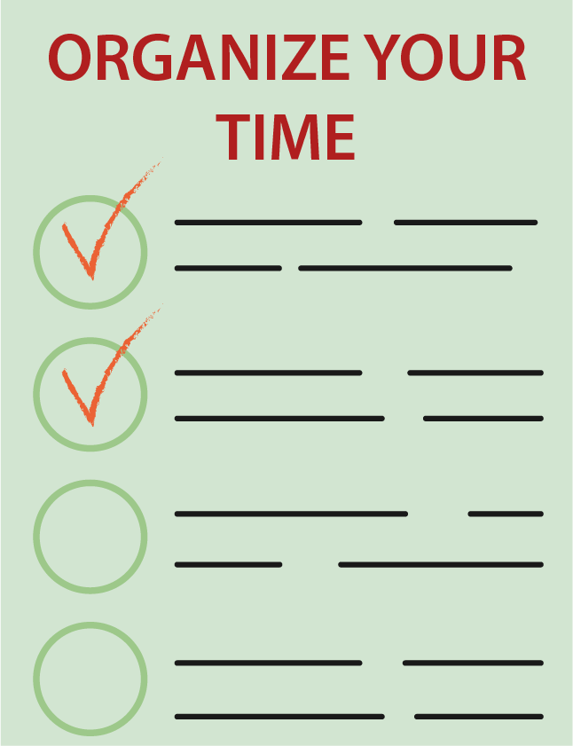Most people waste at least half their study time, because no one has ever shown them how to organize their work. This is the purpose of this chapter—to cut the waste out of your study, and make sure you get a full minute’s results for every minute you spend with your books.

## A. What is organization?

**Organization is simply *planned direction.*** It is a pro­cedure. A system. A planned schedule of events or tasks, one after the other, that gets something done in the shortest possible time, with the least amount of waste.

It is doing the right thing at the right time. And not wasting your time doing the wrong thing.

In regard to your work, therefore, organiza­tion is basically a way of sitting down at a desk,

finding out what has to be done,

opening the right book to the right page to do it,

starting to do it at the beginning.

learning it step by step,

knowing when it is finished and when it is right,

and then remembering what it is you have done, how you have done it, and what use you can put it to tomorrow.

Without such a definite step-by-step plan of attack, you must waste time. Because you will not get down to work immediately. You will not be sure exactly what it is you are supposed to learn. You will wander aimlessly till you stumble on it. And then you may lose it again, or waste time reading on after you have learned it, or forget it before you get to class the next time.

Therefore the most beautiful thing about organization is that it is *far simpler and far easier* than what you are doing today. It not only gives you higher grades—instantly—but it does it with far less study time.

And it’s so easy to put into practice. All the organization you need can be broken down into two simple formulas:

1. Getting down to work; and

2. Doing the work right.

Let’s look at each of them in turn.

## B. No more crises. No more fear

Any subject becomes easy if you organize it on a long-term basis, day by day, lesson by lesson, step by step. Constant, daily study periods, therefore, are the first magic key to success.

The first step in organizing your study habits is to set up a daily work schedule for yourself, and make sure you stick to it. There is just no substitute for regular daily study—for a certain amount of time spent daily on each subject. Life as a student becomes incredibly easy if you maintain a steady pace from start to finish of the year. Then there are no sudden pressures to get things done. No near-hysteria about deadlines. No tensions and anxieties in class.

With a daily work schedule, religiously enforced, all these crises are miraculously replaced by the wonderfully secure feeling of being adequately prepared. Which, in turn, leads to a steady, comforting flow of high marks.

Let’s take a closer look at that daily study period and see how we can make it produce twice the results for you.

## C. Tips that double the value of each study hour

1. Youwill not do top work in your study period unless you make that study period a top priority:

2. You must have a definite place to study. It must be your place. The same place each night. With no one else having any claim to it for that hour.

3. It must be comfortable and bright. With the physi­cal equipment you need to read and write permanently stored there, instantly at hand when you want to use it.

4. There must be no distractions for that hour. This means, ideally, your own room with the door closed. No radio or TV. No interruptions. No friends working with you. No phone calls permitted for any reason. When you get down to work, you stay at work till you are finished. If you do not have your own room, then you must be given the exclusive use of one room for that hour. This means no other members of the family with you. No conver­sations near by, no rustle of newspapers. You need silence to concentrate. And you have to make whatever sacrifices are necessary to obtain it.

5. But this ruling out of distractions goes one step further. It also means that you have with you, at study time, only the equipment you need and nothing more. No unneces­sary books. No newspapers. No pretty pictures on the wall to draw away your attention. Study is business — all business.

6. Make sure you start your lessons at the exact same moment every day. A five-minute delay can kill an entire study period. The phone conversation is cut off, and you are at your desk at the precise moment you are scheduled to be there.

7. You are setting up a routine. A constant, daily psychological readiness to study. An automatic ability to concentrate that can only come from getting down to work at the same time, in the same spot, every day. Once this routine is established, waste motion is eliminated and work flashes by. At the end of that period, when you are ready to review that work, you will be delighted at the quantity and quality of it.

## In summary:

Organization is planned direction. It is your ability to:

1. Get down to work without waste motion, and

2. Get the work done right.

In this chapter we have seen that organization makes even the hardest subjects easy by attacking them on a day-after-day basis. In order to do this, a definite study hour must be set aside every day, at exactly the same time, in exactly the same spot, with exactly the same equipment. Once this routine is established, getting down to work becomes instant and automatic. You are ready to slash into your work without a second’s waste motion.

*Now let’s learn the second part of organization: How to fill up that study period with achievement. How to do that work right.*

*We’ll start with the basic art of reading. How to cut through it in half your present time, with absolute under­standing of every word you read.*

PART TWO  
DIGGING OUT THE FACTS — READING

# I. How to Become a Master Reader

## A. In three easy steps

The basic, fundamental skill required for all education is reading. Your ability to study effectively, to get top grades in any subject, depends almost entirely on your ability **to read thoroughly** and **with understanding**. On your ability to **pull facts out** of a printed page and make them your own.. Even in mathematics, your must first read the in­structions and then understand precisely what you are to do to solve each of the problems. It you cannot do this, if you cannot read any assignment with complete confidence and understanding, then you will go through the rest of your life suffering from these two crippling handicaps:

*You will be forever doing unnecessary work. Every assignment will become doubly difficult—read over and over again two or more times, with each sentence painfully spelled out and only partially understood. And*

*You will be forever making unnecessary mistakes. Teachers acknowledge that almost as many errors are made in homework and tests through sheer misreading or mis­understanding of instructions alone as through lack of knowledge.*

Here’s why.

## B. Good reading is far more than merely recognizing words

Mere mechanical reading is not enough. Passive reading is not enough. The ability to run your eye over a printed page—to make words out of the print on that page and put them together into sentences— is only the beginning of effective reading.

Effective reading is far more than this.

Effective reading goes one step beyond mere words.

Effective reading is the art of taking those words, and boiling them down into thoughts.

Of boiling down dozens, and even hundreds, of those words into one vital thought.

*Of searching for the “guts” of an assignment—the two* ***or three*** *really* ***important thoughts*** *that it contains—and separating them from all the waste words and unnecessary details that surround them.*

*And then burning those few vital thoughts into your memory, so you can never forget them.*

## C. Good reading is a search. A search for big ideas

Let me repeat these all-important facts. You must be trained, not merely to read for words, but for *central thoughts.* You must learn that good reading is an active, ag­gressive search that has these three steps:

1. Locating a main idea in the mass of words that contain it.

2. Separating that idea from its unnecessary details. And

3. Boiling that idea down into a few easily remem­bered words.

You become a good reader, therefore, only when you master this technique of searching and boiling down. Searching and boiling down. Searching and boiling down until you have taken the entire assignment—hundreds upon hundreds of words, sentences, and paragraphs—and reduced them to a few vital thoughts that contain the meaning of them all, that sum up the meaning of them all. And that can be burned into your memory forever in a few short moments. Ready to be put to use—to solve new problems or to answer questions in an examination—the very instant you need them.

**This is a new way to read. Twice as fast. Five times as effective.**

## In summary:

Good reading is far more than merely recognizing the meaning of words.

Good reading is an active, aggressive search for the *major thoughts* that are contained in these words.

This search has three steps:

1. Locating the main ideas.

2. Separating them from their unnecessary details. And

3. Boiling them down into a few words that can be easily memorized.

Now let’s put these three steps into action. Let’s examine each of these techniques in detail, along with concrete ex­amples of what they will accomplish for you.

# II. How To Pre-Read A Book — Understand It Before You Read It

Let us suppose that you are given a reading assign­ment. For example, you are told to read a Chapter in *The Old Testament Speaks* by Schultz. Or the next five pages on fractions in your bookkeeping course. Or perhaps even a com­plete book report on *The Master’s Plan of Evangelism* by Coleman.

You take the book home. You sit down at your desk at the exact moment your study hour begins. And you open the book to the page assigned.

*What do you do now?*

If you simply begin to read the first words you see on a page—if you plunge right into that text without making any further preparation—then you are making a crucial mistake that will cost you hours of waste effort every week, and that may cause you to miss the entire point of each lesson. No one—no matter how bright—can really understand an assignment by simply beginning to read it word after word. It’s like trying to go on a car trip by simply driving on to the first highway you see, without getting directions or looking at a road map.

*Your first fob in reading is to get those directions. To build yourself that road map. To know exactly what you want to get out of that lesson. And where it’s located. To do this, you pre-read that lesson. You glance over that lesson from beginning to end—before you start to read it. And you pick out the following information:*

1. What’s the main theme of this lesson? (For example, the Patriarchs.)

2. How much information does this lesson cover? (The period from Abraham to Joseph.)

3. What are the main *thoughts* in this lesson that I have to remember? (Major events in the lives of the patriarchs.)

4. How many of these *main thoughts* are there? (About nine or ten.)

5. What do I have to remember about each one of these patriarchs? (Relationship to the Abrahamic Covenant.)

6. Where in the lesson do I find this information? (Now *you begin to read.)*

## A. Just look at the difference these few questions make.

Now, what exactly has happened here? Youhave invested one or two brief minutes to glance over your lesson from beginning to end. In that short time, you have picked out its main theme and each of its central thoughts. You have built a skeleton of that lesson—an outline of that lesson— a road map of that lesson to follow as you read.

Now you know what you are looking for. Now you are walk­ing a lighted path instead of stumbling in the dark. Now, instead of facing a confused jumble of words, you slash through that lesson with this definite purpose in mind; *what do I have to remember about each one of these main Caesars?* (what was their relationship to the new testament?) Now you read to answer this question. You have *direction.* In one or two minutes, you have a better grasp of that assign­ment than if you read it aimlessly for a full hour.

## B. Signpost parts of every book. And what each one tells you

How do you find these main thoughts: Fortunately, the authors of your books agree with this road map idea. There are sign­posts in the book that point them right out to you.

#### 1. The title

*What it tells you:* actually, a good title should give you, in a single phrase, the main theme of the book. What it is about, and what it is not about. It is your first concrete in­formation about what you are to learn in the pages that follow. Make sure you understand it before you read on.

#### 2. The table of contents

*What it tells you:* the table of contents takes the grand plan, the ultimate goal you are shooting for, and breaks it down into a step-by-step process. It shows you the steps you have to take, one after another, to attain that goal.

This table of contents is actually a ready-made outline of the book that should be studied carefully before you read one word of its text. By carefully going over this table of con­tents, you immediately

A) gain an over-all picture of the skeleton of the book;

B) see the relationships between each of the various chap­ters and the main theme of the book;

C) know exactly where you are going when you start to read—to such a degree that you can even set up a time schedule of so many days per chapter to finish the book when you have to.

*For example:* in Schultz’s Old Testament Survey book, the table of contents is broken down into chapters, and then into main parts.

Let’s start with the main parts first, and see how they relate.

#### 3. The index

*What it tells you:* the index is a storehouse of minor topics of special interest to you. There they are alphabetically arranged for instant reference. *For* *example:* glance at the index of Schultz. Pick out a topic of special interest to you, or a problem that you are facing today. For instance, take the patriarchs*.* Look “patriarch” up in the index. Turn to the pages indicated there. And *glance at, do not read,* the treatment given to you.

Instantly you can see the concrete, step-by-step methods that make it easy to remember those patriarchs. There’s no need to read them, word by word, now, since you’ll get up to them later this week. And in the proper time and place in the book, they’ll mean far more to you. But now you know that they’re there, and that they’re complete. And if you ever have to refer back to them after you finish the book, the index will tell you where they’re located at a glance.

And now we turn to the last of our big signposts:

#### 4. The introduction, or preface, or foreword

*What it tells you:* this is the author’s personal message to you, before you get down to the body of the book. In it, he may

Explain why he chose this particular title,

Or tell you what compelled him to write the book,

Or show you in advance what he is trying to accomplish,

Or give you a brief, one or two paragraph condensation of its contents,

Or list the main sources from which he got his informa­tion,

Or list the reasons why this book should be important to you,

Or in any other way give you a brief outline of where you will be heading in the book and what benefits it will give you.

It is the personal note, the personal touch that rounds out your quick survey of the book and gives you insight into the author himself and his purpose in writing the book, as well as its contents.

## In summary:

No matter how bright you may be, youcannot understand your assignments simply by reading them word by word. Instead, you must first *pre-read* those assignments—make a quick survey of them *before* you read to uncover their main thoughts.

You do this, not only with each chapter you are assigned, but with each new book that you study. You find the main ideas of each of these books by check­ing the following four signpost parts of every book:

1. The title

2. The table of contents

3. The index

4. The introduction or preface

When you lift these signpost parts out of the text and arrange them in order, you will have at your fingertips an outline of the main thoughts of that entire book. You can then read each individual chapter in order, with perfect understanding of how it ties into the chapter that has gone before it, the chapter that follows it, and the main theme of the book as a whole.

*Now let’s see how easy it is to pull out the main thoughts of each chapter in the exact same way.*

# III. Signpost Parts Of Every Chapter

NOW LETS GET TO WORK ON THOSE CHAPTERS.

HERE’S HOW THE CHAPTER SIGNPOSTS BREAK IT DOWN FOR YOU*,* IN MIN­UTES.

As you could tell at a glance, it’s simply not enough for you to just read these chapters, word by word, from start to finish. If you try to do this, you will confuse detail with main idea, and you will remember almost nothing when you are through reading. *What you need is a key—a system—that will un­lock that mass of words and pull out the main ideas for you. This key is PRE-READING. The ability to read chapter signposts at a glance, and use them to pinpoint the main ideas of the chapter, one after the other, and give purpose and direction to your reading.*

There are eight signpost parts of every chapter that you should know as well as your own name. Let’s re­view them one by one, and see how they pull the main ideas right out of these chapters *before* you begin to read the text.

### A. The chapter title

*What it tells you:* what the chapter is about. What it includes and does not include.

### B. The section headings

*What they tell you:* the section headings break down the over-all chapter heading into its main parts. They list the names and number of important subjects to be covered in the chapter. Reading them quickly, without the intervening text, gives you the skeleton of the chapter.

### C. Paragraph heads or bold prints

*What they tell you:* the main topic of each paragraph. What the paragraph contains boiled down into a single phrase.

### D. Introductory paragraphs

*What they tell you:* here the author points out to the student what to look for in the text that follows.

Usually you would next check:

### E. The summary or closing paragraphs

*What they tell you:* the summary paragraphs are the author’s last words on the chapter. They are his own outline of the material he has covered in this chapter before he passes on to the next. They are a declaration of what *he* deems important out of all the material you have just read. Sometimes he sums this material up in one paragraph. Sometimes he outlines each idea in a separate phrase, para­graphs it, and may even number it. Sometimes he rephrases the important points in the form of questions. In any case, these final words deserve careful study *before* you begin reading the text.

### F. The first sentence of each paragraph

*What it tells you:* as you remember, this pre-reading, this quick survey of an entire chapter before you begin reading the text, is essentially a search. A search for the main thoughts of that chapter—for a quick outline of that chap­ter that tells you exactly what you are looking for and where to find it. This search begins with the chapter title, and continues, one by one, with each of the following chapter signposts till you have uncovered those main ideas—till you have built your outline.

At this point, when you have located the main ideas in the chapter, you stop the pre-reading and begin reading the text. The pre-reading is a search for the chapter’s main ideas. When you have found them, you begin to read.

Therefore you do not check **all** the chapter signposts in each pre-reading of each chapter. You check only *enough signposts* to give you **your main ideas**, and then ignore the others.

### G. Illustrations

### H. Marginal titles

### I. Reading the text by evaluating sentences

You are looking only for big contributions, not details. Therefore you will judge each sentence by these two simple rules:

*It must talk about the main theme of the chap­ter, and not about some side issue.* In this case, they must talk about the patriarchs’ contribu­tion to the background of the Israelite nation, or about the geographical contribution to that background, and about nothing else.

It must bring in a new main point, and not merely furnish details about a main point brought up by the paragraph before.

These are the two rules of what to leave in and what to throw out. They are quite simple to follow.

### In summary:

When you are reading an individual chapter or lesson in a book, you use the same Pre-Reading, quick-survey technique that you first used to understand the book as a whole. You use this quick-survey technique to pull out the main ideas from the chapter before you begin to read it.

You find these main ideas by checking the following eight chapter signposts:

1. The Chapter Title

2. The Section Headings

3. The Paragraph Headings or Bold Prints

4. The Introductory Paragraphs

5. The Summary Paragraphs

6. The First Sentence of Each Paragraph

7. The Illustrations

8. The Marginal Titles

When you lift these chapter signposts out of the text and arrange them in order, you will have an outline of the main thoughts of that chapter at your fingertips. You may then flash-read that chapter—merely skimming over the unimportant details—and concentrating only on definite information on each of these main thoughts.

*We now turn to a simple trick that will automatically show you exactly what information you must look for on each one of those main points.*

# IV. Speed Reading

## A. Turning signposts into questions

At this point, you have the main ideas of each chapter at your fingertips. But your knowledge of the chapter is, of course, still incomplete. Now you must read the text itself, to find out what you should know about each one of these main points. And how do you tell—again in advance of actually reading the text—exactly what it is that you should know about each one of these points?

The answer is simplicity itself. You merely

1. Turn each one of these main points into a question. And then

2. Read the text to find out your answers.

It’s as easy as that. Now let’s see this question-and-answer technique in action.

## B. The six basic questions

Any idea—any word, any phrase, any sentence—can be turned into a question simply by putting in front of it one of these six little words:

What?

Why?

Where?

When?

Who?

How?

You have now finished your quick survey of the chapter. You have pulled out its main thoughts and turned them into questions. You are now ready to read the text, word by word, to answer these questions. Let’s see how you do this, in the shortest possible time, without missing a single vital point.

## C. How to double your reading rate

Since you will be faced with a flood of paperwork in your lifetime, *now is* the time to build in that speed. Here are five simple tricks that will do it for you automatically:

1. Don’t you *point out* the words with your finger or a pencil! This slows you up. Read *with your eyes only.* This means your hands must be folded till you turn to the next page.

2. Keep from moving your lips or your mouth. Lip moving slows reading speed down to speaking speed. If it’s difficult for you to stop moving your lips, bite a pencil while you read till you lose the habit.

3. Don’t move your head from side to side. This tires you out and again slows up your reading. *Only your eyes should move. Only your eyes need to move.*

4. Learn how to read aggressively. Actively. Tearing the ideas out of the pages with the techniques we are show­ing you in this lecture.

5. Learn the habit of skimming and then concen­trating as described below. Make every reading assignment a search for main thoughts through a forest of useless words. Skim through 90 per cent of those words, and con­centrate only on the vital 10 per cent.

And then practice. Practice—practice—prac­tice. Till you become an expert. Till these habits become second nature. Till you can zip through any written page, anywhere. Like this.

## D. How to flash-read

Cut through unimportant details in seconds

Now with these speed-reading skills firmly implanted in your mind as automatic habits, you begin to attack the chapter, word by word. You begin to read as fast as you can. You read every word. But now you are sifting those words—judging them— accepting them or rejecting them. You are looking for specific answers to specific questions— the questions you constructed in your quick survey before you began to read.

## E. The magic key to concentration

As you remember, you are reading to find specific answers to specific questions. Every sentence you read is judged on that basis. Does it answer your questions, or does it not? If it does not, you flash-read it, and search on for your answers. If it does, however, you slow down, concentrate your full attention on that sentence, *and pick up your pencil to underline the answer.*

This deliberate physical act—this aggressive underlining of answers in the textbook as you read them—is the golden rule that makes your concentration automatic. It converts routine reading into active, physical thought. It prevents your mind from wandering. It makes the dead, lifeless material in the book come to life with the thrill of personal discovery. It forces you to evaluate, weed out, judge, emphasize. It is the first great step in turning that ma­terial into *your own personal acquisition* as you hammer it out, answer by answer by answer. And it is as easy as abc. There is only one simple pro­cedure to follow.

Every time you find the answer to one of your questions, you simply:

A) read it carefully.

B) make sure you understand it. And

C) underline once the specific words you are going to use to remember it.

That’s all there is to it. On an entire page you may underline only one or two sentences. In a complete chapter, you may make only four or five marks in your book.

## In summary:

Once you have made your Pre-Reading survey, with its questions to be answered, the actual reading of the lesson becomes incredibly fast and easy. During this reading, you will skim over about 90 per cent of the text, searching only for the answers to your main-thought questions, and letting their details stick to your memory automatically. And when you find a main-thought answer, you actively underline it, marking each word that you will use later to remember it by. In this way, you actively build up a series of main-thought answers, *which you will now use to build a Main Thought Outline in your notebook so you can remember them as long as you wish.*

It is to this last step of rewriting and remembering that we now turn.

Part Three  
Planting Concepts—Note-taking

# How To Take Notes

## A. How to remember what you’ve read and put it to immediate use

You are now ready for the pay-off, the moment when you master the meaning of the chapter and make it your own. What have you done so far? All this:

1. Picked out the main thoughts of the chapter. ,

2. Turned them into questions.

3. Weeded out material that did not answer those questions, and which you will never have to look at again.

4. Located the answers to those questions—the vital information that composes the backbone of that book.

5. Marked that vital information separate from the rest of the chapter.

You now have everything you need to know about every main thought in that chapter right at your fingertips. Now you have to fit them together. Now you rewrite the chapter, in your own personal language, making fifty words do the work of five thousand.

## B. Your notebook

Where you re-create the back-bone meaning of each chapter, each book, each course

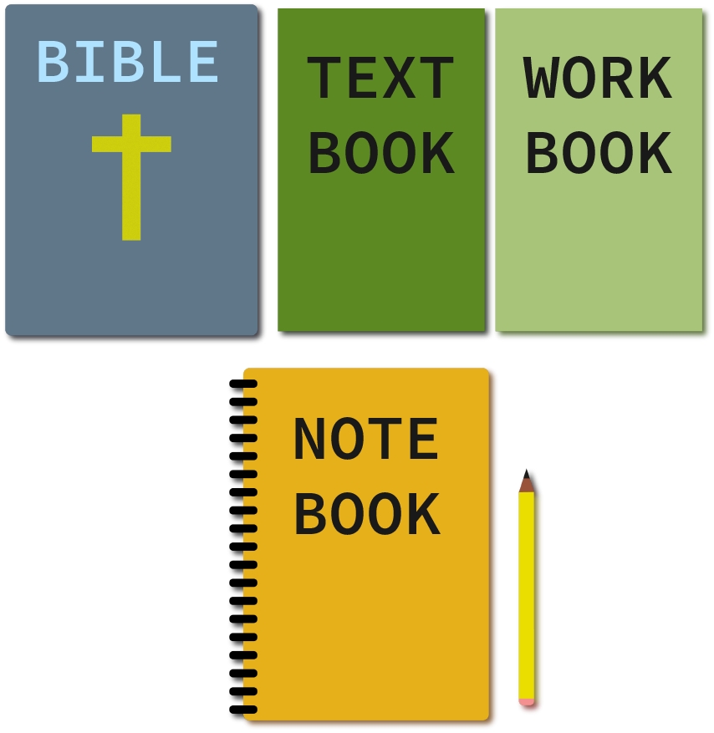In addition to your own mind, you have only 5 basic tools to open up the entire world of knowledge to your grasp:

Your Bible

Your textbook

Your workbook

Your pencil, and

Your notebook

## C. How you write up each lesson in your notebook

After the assignment page, for each course, come the main thought outline pages you will write up, day after day, as you master that course. These pages are not haphazard in any way. They are not written in the classroom, not written while you are actually reading the text. There is no room on them for illegible scrawls, written daydreaming, or doodles of any kind. They are carefully and precisely prepared, in this way:

1. When you have finished reading the chapter, and when you have underlined the answers to the main-thought questions that you had previously prepared, you then *close* the textbook.

2. You are now ready to put your knowledge of the back-bone of that chapter to its first test. To do this, you take a *blank sheet* of paper—not in your notebook—and *from memory* you write down each of the main thoughts of that chapter and the information you have learned about them.

3. You will forget some of these points. You will write down some of them out of order. You will find that you still don’t clearly understand some of the information about them. None of this is important. What is important is the fact that you have just made your *first recitation*, taken your *first self test* on that chapter.

4. You now go back to the text and check and *correct your outline*. You write the corrections directly onto that rough outline and close the textbook.

5. When you have finished it, when you have it boiled down and correctly arranged it to your own satisfaction, then you put that paper away. Now you open your notebook. And you write that outline—again from memory—on one page of that notebook.

6. What you are doing is *freeing yourself*, step by step, from the crutch of that textbook. You are transferring knowledge out of that textbook into your own memory, and then into your notebook for instant reference. And each step of the way you are ***condensing*** that knowledge, ***memorizing*** and re-memorizing it, ***understanding*** it more deeply and clearly with each word you write.

7. When you have finished writing the outline in your notebook, you check it again with the textbook. If there are one or two errors or omissions, you write them in. If there are too many, you rewrite the entire page. You write on only one side of the paper, however, because you will use the other side later to double the profit you get out of every hour of review.

And then, when you have the outline in your notebook finished to your satisfaction, you close both books and are finished for the night. You have learned your chapter. You have the backbone of that chapter stored in your memory and your notebook, ready to go to work for you at an instant’s notice. And you can show it, in black and white, every time you need it for your five-minute achievement check.

## D. Tips on improving your outlines

#### 1. Simplify

Keep compressing, boiling down, making the outline shorter and shorter. Use phrases instead of sen­tences. Eliminate unnecessary words and details. Blend sub­ordinate sentences into others by boiling them down into one or two words. Keep cutting till each idea stands sharp and clear in a few easy-to-remember words.

#### 2. Fit the ideas together properly

Make sure one idea leads into the other in the right order. Then, when you think of the first idea, the second automatically pops into your mind.

#### 3. What are the kinds of order you can use to make one idea fit in with another?

#### Here are a few:

a. Parts of something.

*Example:*

Kinds of birds:

1. Sparrow

2. Robin

3. Blue bird, etc.

b. Time order

*Example:*

Battles of World War II:

1. Poland

2. Holland

3. France

4. Britain, etc.

c. Step-by-step sequence

*Example:*

How to write your testimony:

1. Using short paragraphs, write about your life before Christ.

2. Write how you met Christ.

3. Write how your life has changed, etc.

d. Causes of something

*Example:*

Causes of fall of Adam:

1. Temptation

2. Pride

3. Disobedience, etc.

e. Effects of something.

*Example:*

Results of fall of Adam:

1. The serpent was cursed

2. Thorns and thistles grew

3. Man would die physically, etc.

f. Arrangement by space

*Example:*

Israelite tribes in the north of Canaan:

1. Asher

2. Naphtali

3. Zebulun

4. Issachar

These are only a few samples. Look for other kinds, and keep a list of them at the back of your notebook.

#### 4. Use numbers

They are a great help, both in under­standing a lesson and remembering it for future use. For example, once you know that there are three patriarchs you related to the OT you realize that you must reproduce all four of them on any future test. If you had not numbered them, however, you may have thought there were only three, and left one out because you didn’t stop to search for it.

#### 5. Indent

And then indent again. Physical indentions show instantly the difference between the theme of the entire chapter and its sub-thoughts. And if these sub-ideas have any further divisions, again indentions show their re­lation at a glance. Notes should be neat and precise, with plenty of white space around each point, so you can see exactly where it stands in relation to the chapter as a whole when you review it.

## E. How you use your notes

When you finish writing up these notes each night, you have accomplished not one but two vital tasks:

1. You have read and understood the chapter assigned to you—and understood it more completely than you had ever dreamed before.

2. You have stored away the backbone meaning of that chapter, so that you can now thoroughly review it for a test by reading as few as fifty words, instead of as many as five thousand.

You have two enormous advantages over every other person in your class who does not use this technique. And you begin putting those advantages to use immediately. Your first review takes place right after you finish those notes, and then when you have your five-minute achievement check that same day.

## F. The next seminar

And the next time, on your way to the seminar, you take one more brief look over these notes. Riding to class, walking through the halls, with your notebook closed, you run through these three magic questions:

*“In* *one sentence, what did I learn from this last chapter?”* (That the five roads to cost reduction are through reducing raw materials costs, manufacturing costs, capital equipment costs, sales costs, and general and administrative costs.)

*“How does this tie in with the chapter before?”* (It’s a second way of increasing profits, right after improved man­agement.)

*“What questions will I be asked on it in next week’s test?”* (To list several ways of reducing costs in each one of these areas. And you run through them.)

Using this planned technique, in half the time that it would have taken you to read that chapter before, you are now ready to go in that classroom and make your classmates’ eyes pop open in amazement.

## In summary:

There is an easy, simple, organized way to master the contents of any assignment. It consists of the following three steps:

1. **Pre-Read** the assignment, to pick out its main thoughts and turn them into questions.

2. **Power-read** the assignment, to weed out unneces­sary details and concentrate on the answers to these ques­tions.

3. Translate the assignment into a **Main Thought Out­line** that expresses these answers in as few words as possible, and that is stored for instant review in your notebook.

These are the three Magic Keys to Expert Reading, You should practice them again and again and again, until they become second nature to you. They will pay you dividends for the rest of your life.

**(See chart below)**

## Want to Check Your Study Habits?

|  |  |  |  |
| --- | --- | --- | --- |
|  | **Seldom or Never** | **Sometimes** | **Usually or Always** |
| Do you set aside a certain time for study? |  |  |  |
| Do you study other sources than your Bible and your workbook? |  |  |  |
| Do you make brief notes as you read? |  |  |  |
| Do you classify this information in a way that will help your thinking? |  |  |  |
| Do you look up new terms, learning pronunciation as well as meaning? |  |  |  |
| Do you read carefully and to get the meaning of what you read? |  |  |  |
| Do you question comments which you read and try to learn whether they are based on facts or opinions before you accept them as true? |  |  |  |
| Do you pray at least once a day about your lesson for the coming week? |  |  |  |
| Do you have a certain time when your lesson preparation must be completed? |  |  |  |
| Do you check your method of study to see whether it can be improved? |  |  |  |

Blessings to you, our dear friends!

We are happy to present the video, audio and paper materials that have been prepared by New Life for Churches. You have the privilege *upon completion of your practical assignment* to use this lecture with others.

Practical assignment

|  |  |
| --- | --- |
|  | Completed |
| * Study one book of your choice according to the “Successful Study Habits” method.   Mark *Master Plan* or another book properly according to this lecture. Present a sequence of all your reading notes, (not just a final copy - this has to do with how much money should be subtracted for tardiness) | 🞎 |
| * Based on the ideas for improvement that you wrote down on your questionnaires and discussed, begin to make improvements in your study habits. At the end of each week write a paragraph explaining what you have done to improve the quality of your studies during the last week and whether you feel this improvement has helped you or not. Also write down what you intend to do the next week to improve your study time. Bring these reports to the next meeting. | 🞎 |